Additional Stat Min Considerations

for Districts of Innovation

Districts of Innovation who display less than 187 Days Employed on the Job Info screen for teachers, full-time librarians, full-time counselors or full-time nurses, should use the following procedure to calculate Stat Min accurately.
Complete all steps in Next Year Payroll

- From Utilities > Mass Update > Employee tab change Number of Days Employed to 187. Consider using Extract IDs and Pay Type 1 in the Parameters area to ensure updating the correct groups(s) or employees.

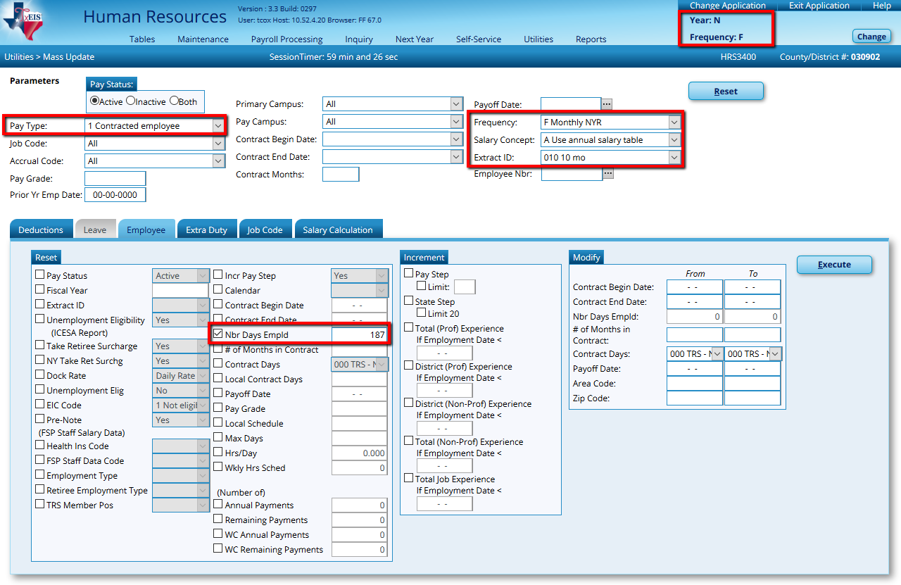

Click Execute and at the preview, select Process.

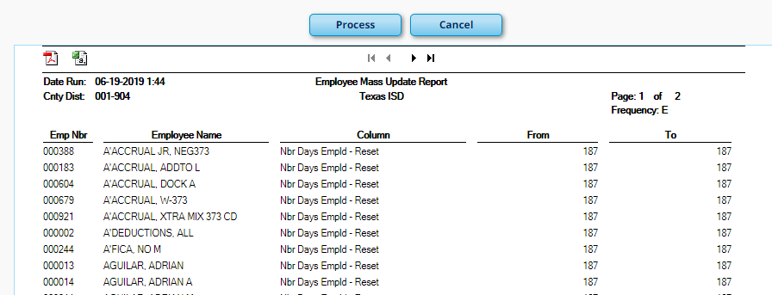

- From Utilities > Mass Update > Salary Calculation tab calculate State Minimum only.

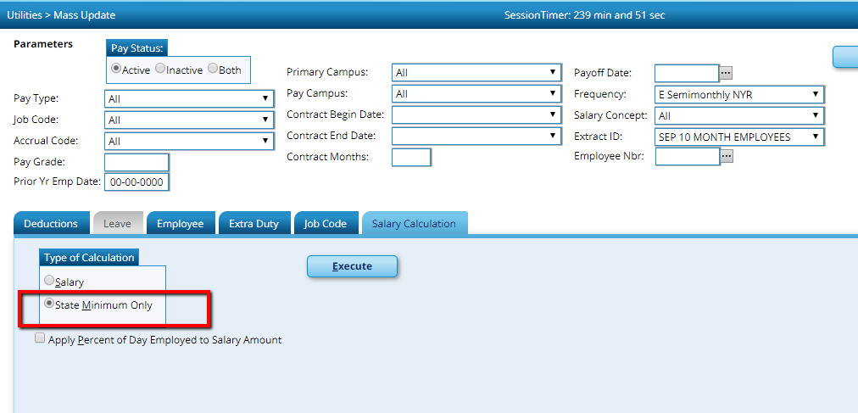

Click Execute and Process.

- Return to Utilities > Mass Update > Employee tab and change the number of days employed back to the actual number of days employed (less than 187). Execute and Process.
The Stat Min calculated on 187 days will be retained unless you re-calculate. Please note: Any time you go to an employee’s job info screen, the system will ask you if you want to Change the Stat Min Salary. Check NO to retain the correct Stat Min.

